Лабораторная работа 4.2

Задание 1 Фильтр: заказы 1-го квартала 2016  
SELECT *

FROM Orders

WHERE Order_Date BETWEEN '2016-01-01' AND '2016-03-31'  
Строк достаточно много, вывел первые, чтобы показать, что все работает  
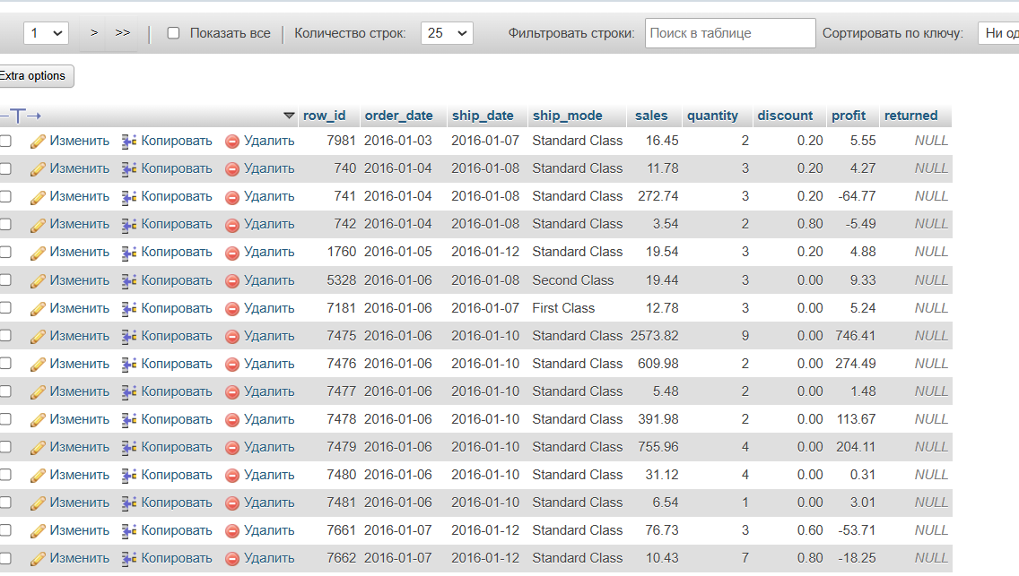

Задание 2 Отчет по регионам

SELECT c.region, COUNT(o.row_id) AS total_orders, SUM(o.sales) AS total_sales,

AVG(o.discount) AS avg_discount, AVG(o.profit) AS avg_profit

FROM orders o

JOIN customers c ON o.row_id = c.id

GROUP BY c.region

ORDER BY total_sales DESC

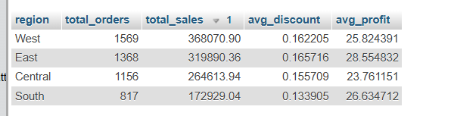

Задание 3 Анализ возвратов  
SELECT

p.category,

COUNT(o.row_id) AS total_orders,

SUM(CASE WHEN o.returned = 1 THEN 1 ELSE 0 END) AS returned_orders,

SUM(CASE WHEN o.returned = 1 THEN o.sales ELSE 0 END) AS lost_revenue,

(SUM(CASE WHEN o.returned = 1 THEN 1 ELSE 0 END) / COUNT(o.row_id)) * 100 AS return_rate

FROM orders o

JOIN products p ON o.row_id = p.id

GROUP BY p.category

ORDER BY return_rate DESC;

